

Dear Parent/Guardian,

STARBASE Maxwell is a 5-day academic program designed to enhance children’s learning in the specific areas of Science, Technology, Engineering, and Mathematics (S.T.E.M.). The STARBASE curriculum is aligned with national standards in mathematics and science as well as enhancing state curriculum. During your child’s visit, he/she will be engaging in hands-on activities that are all designed to motivate them to continue learning in the S.T.E.M. fields.

Attending Dates____________________________________________________________________

While your child attends STARBASE Maxwell, please note the following important information:

Attendance: Students will be transported by their school to our Maxwell AFB facility.
Please note: For the safety of the student, it is required that all students in attendance arrive and leave with their class on the school bus each day. If your child becomes sick at STABASE Maxwell, their teacher will contact you and the school to determine the best way for the child to be picked up. For directions to the base, please google Maxwell AFB Visitor Center.

Parental Attendance: STARBASE is an academic field trip with limited space and strict time constraints. Due to this and security measures, parents are not allowed to attend.

Clothing: Students should wear comfortable, weather appropriate clothing. Closed toe shoes with socks are required. Dresses and skirts are not recommended however, if must be worn, please wear shorts underneath. Students may want to bring a lightweight jacket, as our classrooms can get chilly. Mask requirements will depend on base protocol at the time of your child’s trip.

Lunch: If a student brings a lunch from home, please pack it in a lunch bag/box in order to keep it cold. DO NOT SEND FOOD THAT REQUIRES HEATING. *Students can use the water fountain to refill water bottles, but cannot drink from it. Please send a refillable water bottle (with a lid that closes) with your child.

Supplies: None are required! STARBASE Maxwell provides all the supplies your child will need.

We are looking forward to having your child attend STARBASE Maxwell. Should you have any questions about the program, please direct them to your child’s teacher.

Visit our website at www.starbasemaxwell.org for other programs we offer such as STARBASE 2.0, summer camps, and outreach programs.
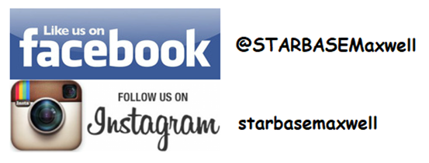

Kirk Alexander, STARBASE Maxwell Director
60 West Maxwell Blvd. Building 835/Basement
Maxwell AFB, AL 36112
334-953-4072
starbasemaxwell@montgomeryed.org
@STARBASE Maxwell

