Montgomery County Parks and Recreation
and
STARBASE Maxwell

are excited to offer Droneology as part of the summer camp program


Who can participate?

- Youth between the ages of 12-14


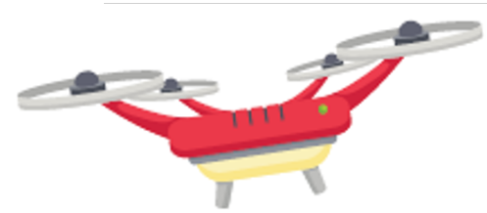

What you’ll learn
- How drones are used
- The science behind flying
- Drone rules and laws
- How to fly a drone!

Talk to a Parks & Recreation representative today: 334-832-7183

