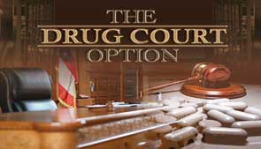

WHAT IS DRUG COURT?

The Montgomery County Community Corrections Drug Court Program is a court supervised alternative to traditional criminal prosecution and is designed for nonviolent offenders who have been charged with drug possession and/or drug related crimes. Participation is voluntary; a minimum of twelve months; and participants should desire a change in their thinking and lifestyle.

Those who successfully complete Drug Court make significant progress in terms of employment, education, and living a stable and drug-free lifestyle.

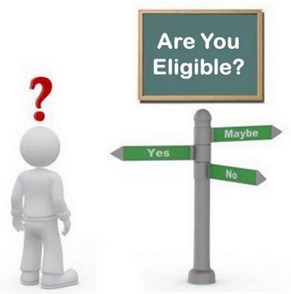
WHO IS ELIGIBLE?

- Offenders that have a substance use diagnosis.
- Offenders charged with a drug offense, property offense, or other non-violent offense where drug abuse was a motivating factor.

Offenders with other charges will be screened on a case-by-case basis.

WHO IS NOT ELIGIBLE?

- Non-drug/alcohol users.
- Violent offenders.
- Juvenile offenders.
- Sex offenders.
- Offenders who have prior domestic violence or child abuse convictions.
- Offenders currently on probation or parole supervision.
- Offenders charged with offenses where a weapon was used during the commission of the crime.
- Drug dealers or offenders that enter a plea of guilty for Trafficking, Distribution, Manufacturing and/or Furnishing of illegal drugs. Other factors to be considered include the nature of the charge, the amount of drugs involved, and the applicant’s ability to complete program requirements.

LENGTH AND PHASES OF DRUG COURT:
Participation in Drug Court can last up to 12 months; however, program progression is awarded to those offenders who are:
- compliant with program requirements,
- meeting treatment goals,
- active in recovery.

BENEFITS:

DRUG COURTS:

- Offer diversion from the ordinary course of prosecution.
- Treat substance use disorders.
- Treat mental health needs.
- Help break the cycle of addiction in families.
- Deliver services for lifelong recovery.
- Relieve jail overcrowding.
- Reduce re-arrests and re-incarcerations.
- Produce tax-paying, productive citizens.

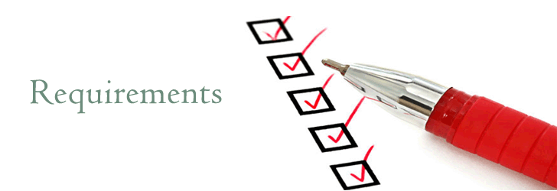
Each Drug Court Participant must:

- Enroll in and complete a treatment program prescribed by the Court.
- Attend self-help/support meetings.
- Submit to random drug screenings.
- Remain alcohol and drug free throughout the program.
- Maintain employment throughout the program, if applicable.
- Obtain approval from the Court before leaving the county and/or changing employment or residence.
- Perform community service.
- Pay program fees, if applicable.
- Pay restitution, if applicable.
- Attend all court hearings.
- Follow program rules and comply with all directives of the Court.

Applicants that hold a commercial driver license (CDL) or permit and any other operator of a commercial motor vehicle must surrender license upon program entry (Alabama Act No. 2010-754).

Each Drug Court Participant is encouraged to:

- Obtain a GED or other beneficial job training unless a high school graduate.
- Obtain a valid driver license or state identification.


FROM DRUG COURT PARTICIPANTS:

“I had one foot in a prison cell and the other foot on a banana peel. As far as I’m concerned, you saved me from prison by accepting me into your Drug Court. My experience with Montgomery County Drug Court has given me my life back.”

“Thank you so much for all the time that you spent with me. Thank you for believing in me when I didn’t believe in myself.”

“Your Drug Court Program truly helped me to pull my life back together, maintain a healthy relationship, manage my job and time, and become a well-balanced person again.”

HOW TO APPLY:
- The applicant is to contact the treatment provider, schedule an assessment, and follow treatment recommendation.
- File a Petition to Allow Application to Drug Court with the original judge of assignment.
- If granted, an Order Allowing Application to Drug Court will be signed and filed.
- Complete the Drug Court Application and file a copy of the face sheet (front page only) with the Circuit Clerk.
- Submit the Drug Court Application (original document) to the Deputy District Attorney assigned to the applicant’s case(s).
- Once accepted, Orientation and Contract Signing will be scheduled.
Applications are available at the following locations:

- Drug Court Office
- https://www.mc-ala.org/departments/community-corrections/programs

